### **Classroom Activity:** **Implement Expensive Calculator using useMemo**

### ExpensiveCalculator.js

Create a component named ExpensiveCalculator.js that uses the useMemo hook to memoize the result of an expensive calculation.

**Code :**

|  |
| --- |
| import React, { useState, useMemo } from 'react';  // This function simulates an expensive calculation  const expensiveCalculation = (num) => {  console.log('Calculating...');  let result = 0;  for (let i = 0; i < 1000000000; i++) {  result += num;  }  return result;  };  const ExpensiveCalculator = () => {  const [number, setNumber] = useState(0);  const [increment, setIncrement] = useState(0);  // Memoize the result of the expensive calculation  const calculatedValue = useMemo(() => expensiveCalculation(number), [number]);  return (  <div>  <h1>Expensive Calculator</h1>  <input  type="number"  value={number}  onChange={(e) => setNumber(parseInt(e.target.value))}  />  <p>Result: {calculatedValue}</p>  <button onClick={() => setIncrement(increment + 1)}>  Increment unrelated state  </button>  <p>Unrelated state: {increment}</p>  </div>  );  };  export default ExpensiveCalculator; |

### **App.js**

This file will import and use the ExpensiveCalculator component to demonstrate the use of useMemo.

**code:**

|  |
| --- |
| import React from 'react';  import ExpensiveCalculator from './ExpensiveCalculator';  function App() {  return (  <div className="App">  <header className="App-header">  <h1>My React App</h1>  <ExpensiveCalculator />  </header>  </div>  );  }  export default App; |

### **Output**

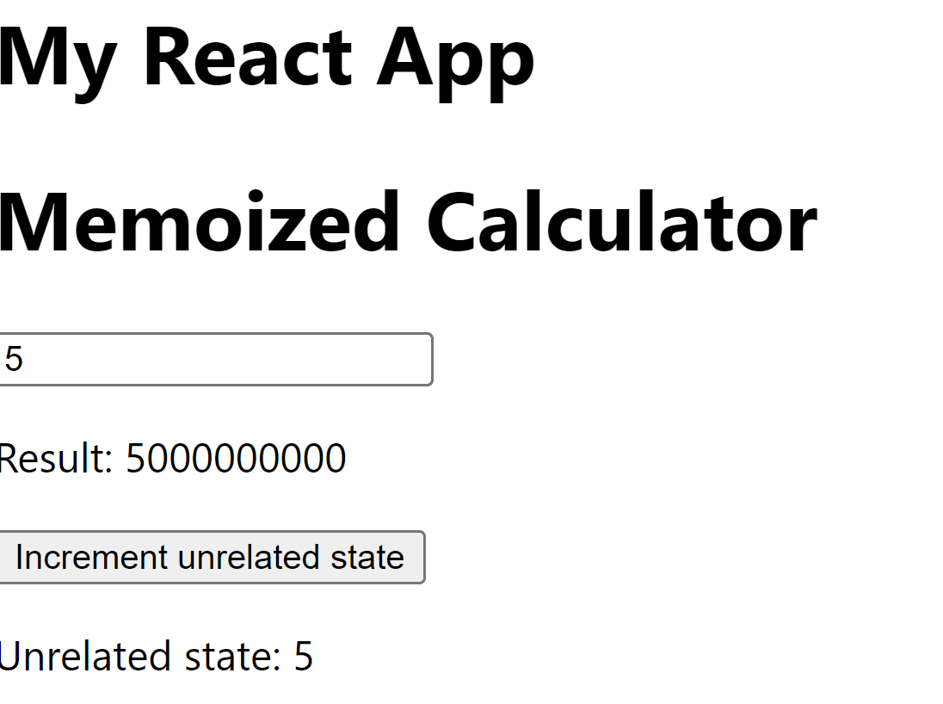

### **Execution Steps:**

1. Create ExpensiveCalculator.js:
   * Navigate to the src folder in your project directory.
   * Create a file named ExpensiveCalculator.js.
   * Write the code for the ExpensiveCalculator component in this file.
2. Update App.js:
   * Replace the contents of App.js with the code to import and use the ExpensiveCalculator component.
3. Save the Files:
   * Ensure that both ExpensiveCalculator.js and App.js are saved after making the changes.
4. Run Your React App:
   * Open your terminal.

Navigate to the project directory and run the command:   
 npm start

1. View the Output:
   * Open your browser and go to http://localhost:3000.
   * You should see the memoized calculator with an input field and a button to increment the unrelated state.